Nathaniel Valla

CPET 343

1. B change level do to the test bench. Then it takes a clock cycle in simulation for a or b to propagate to sig 1. Finally the it takes another clock cycle of simulation for not sig 1 to propagate to c.

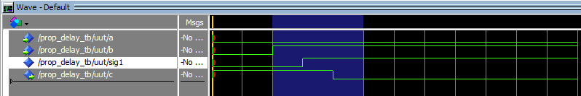

2)

C start as undefined since B not int the sensitivity list so it only changes it value when a changes not when b changes only when a changes

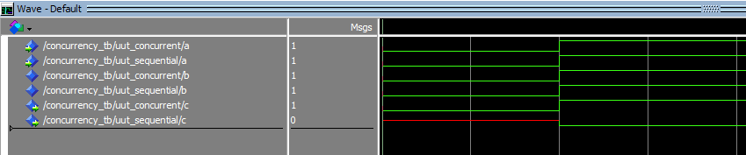

3)

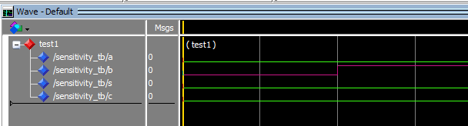

Since B is the sensitivity so c changes because the process runs once more

